# Appendix B: Assets and Liabilities

## Overview

This appendix provides an overview and commentary on Statement 10: Australian Government Budget Financial Statements including estimates of the Australian Government’s budgeted assets and liabilities at 30 June for the current year, budget year and three forward years.

Changes in the balance sheet reflect movements in the budgeted operating result and balance sheet transactions.

A more detailed explanation of major assets and liabilities held by Commonwealth entities, which form part of the Australian Government’s balance sheet, can be found in the Commonwealth Balance Sheet User Guide, published on the Finance website.

Further information on the Government’s fiscal strategy in relation to the balance sheet can be found in Statement 3: Fiscal Strategy and Outlook.

## The Australian Government’s assets and liabilities

### Assets

The Government’s total assets were $790.3 billion at 30 June 2023, and are estimated to be $825.9 billion at 30 June 2024 and $963.2 billion at 30 June 2028.

The composition of Australian Government GGS assets at 30 June 2024 is presented below in Chart 10B.1.

Chart 10B.1: Australian Government GGS asset composition

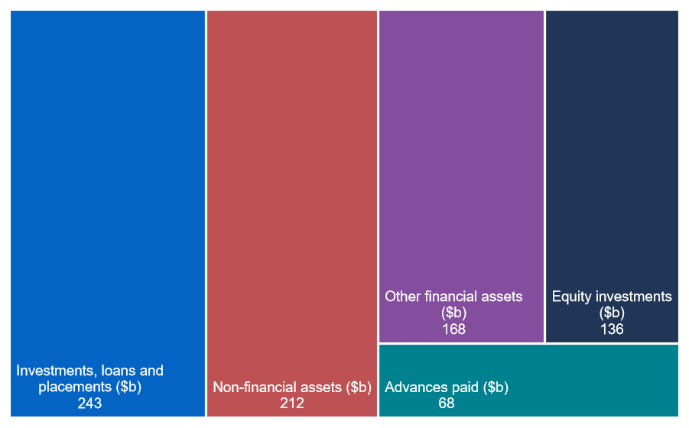

Note: Other financial assets includes cash and deposits and other receivables.

#### Australian Government assets over the forward estimates

The Government’s total assets are expected to grow over the forward estimates due to increased advances paid, investments and acquisitions of non‑financial assets.

The budgeted composition of assets on the Australian Government’s balance sheet is provided in Chart 10B.2 below.

Chart 10B.2: Australian Government assets over the forward estimates

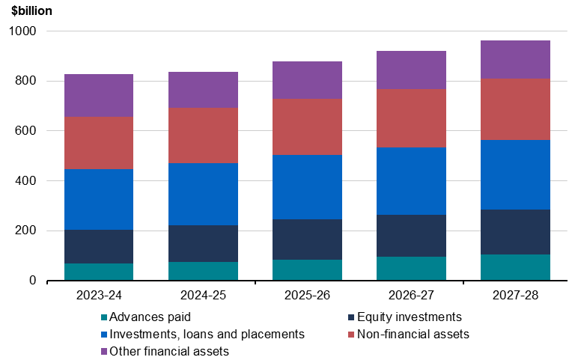

Note: Other financial assets includes cash and deposits and other receivables.

### Financial assets

The Government’s financial assets are estimated to be $614.2 billion at 30 June 2024, increasing to $717.5 billion by 30 June 2028.

Chart 10B.3: Financial assets over the forward estimates

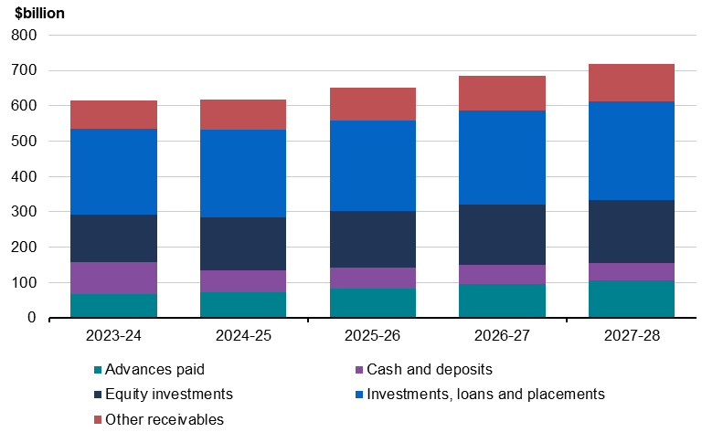

#### Advances paid

Advances paid is comprised of the Higher Education Loan Program and other student loan schemes and loans to state and territory governments. The value of advances paid is estimated to grow over the forward estimates predominantly due to expected growth in student loans.

Further details on loans made by the Government are provided in Statement 9: Statement of Risks.

#### Investments, loans and placements

Investments, loans and placements is predominantly comprised of investments held in relation to the Australian Government Investment Funds, which includes the Future Fund, as well as by other entities, such as the Australian Office of Financial Management, the Treasury and specialist investment vehicles.

Specialist investment vehicles include for example the National Reconstruction Fund Corporation, Clean Energy Finance Corporation, Northern Australia Infrastructure Facility and the Regional Investment Corporation, which provide loans, guarantees and equity injections for projects that deliver public value.

The value of total Australian Government investments, loans and placements is expected to increase steadily over the forward estimates due to forecast investment returns and the investment activities of the Australian Government Investment Funds and specialist investment vehicles.

A breakdown of investments, loans and placements is provided in Note 14 to Statement 10: Australian Government Budget Financial Statementsand further information on the Australian Government Investment Funds is provided below. Further details on loans made by the Government is provided in Statement 9: Statement of Risks.

##### Australian Government Investment Funds

The Australian Government Investment Funds are the: Future Fund, DisabilityCare Australia Fund, Medical Research Future Fund, Aboriginal and Torres Strait Islander Land and Sea Future Fund, Future Drought Fund, Disaster Ready Fund and the Housing Australia Future Fund. Investments held in relation to the Australian Government Investment Funds are predominantly collective investment vehicles, other interest bearing securities and equity investments.

The budgeted value of Australian Government Investment Funds is provided in Table 10B.1.

Table 10B.1: Australian Government Investment Funds balances

|  |  |  |  |  |  |
| --- | --- | --- | --- | --- | --- |
|  | Estimates | | | | |
|  | 2023‑24 | 2024‑25 | 2025‑26 | 2026‑27 | 2027‑28 |
|  | $m | $m | $m | $m | $m |
| Future Fund | 223,602 | 239,192 | 255,866 | 273,702 | 292,784 |
| DisabilityCare Australia Fund | 17,726 | 14,452 | 11,041 | 7,487 | 3,787 |
| Medical Research Future Fund | 22,664 | 23,291 | 23,856 | 24,451 | 25,130 |
| Aboriginal and Torres Strait   Islander Land and Sea Future   Fund | 2,220 | 2,267 | 2,319 | 2,360 | 2,406 |
| Future Drought Fund | 4,813 | 4,957 | 5,119 | 5,264 | 5,424 |
| Disaster Ready Fund | 4,549 | 4,782 | 5,038 | 5,282 | 5,546 |
| Housing Australia Future Fund(a) | 10,291 | 10,303 | 10,338 | 10,323 | 10,323 |
| **Total investment funds** | **285,865** | **299,244** | **313,577** | **328,869** | **345,400** |

1. The Housing Australia Future Fund was established on 1 November 2023.

###### Future Fund

The Future Fund was established in 2006 to accumulate financial assets and invest them on behalf of the Australian Government to address the Government’s unfunded superannuation liability.

The Investment Mandate for the Future Fund sets a benchmark rate of return of at least CPI plus 4.0 to 5.0 per cent per annum over the long‑term. The Investment Mandate gives guidance to the Future Fund Board of Guardians (the Future Fund Board) in relation to its investment strategy. The Board is independently responsible for the investment decisions of the Future Fund. The Investment Mandate also requires the Board to take an acceptable, but not excessive, level of risk for the Future Fund, measured in terms such as the probability of losses in a particular year.

Between establishment and 31 March 2024, the average return has been 7.8 per cent per annum against the benchmark return of 7.0 per cent. For the 12‑month period ending 31 March 2024, the Future Fund return was 10.1 per cent against a benchmark return of 7.6 per cent. The Future Fund was valued at $223.4 billion as at 31 March 2024.

The Future Fund Board continues to maintain clear objectives and manage the portfolio in line with its mandate and strategy. Table 10B.2 shows changes in the asset allocation of the Future Fund since 31 March 2023.

Table 10B.2: Asset allocation of the Future Fund

|  |  |  |  |  |
| --- | --- | --- | --- | --- |
|  | 31‑Mar‑24 | 31‑Mar‑24 | 31‑Mar‑23 | 31‑Mar‑23 |
| Asset class | $m | % of Fund | $m | % of Fund |
| Australian equities | 22,523 | 10.1 | 17,913 | 8.8 |
| Global equities |  |  |  |  |
| *Developed markets* | 45,409 | 20.3 | 34,536 | 17.0 |
| *Emerging markets* | 15,159 | 6.8 | 11,955 | 5.9 |
| Private equity | 33,490 | 15.0 | 33,320 | 16.4 |
| Property | 12,744 | 5.7 | 13,118 | 6.5 |
| Infrastructure & Timberland | 21,280 | 9.5 | 19,166 | 9.4 |
| Debt securities | 24,675 | 11.0 | 16,706 | 8.2 |
| Alternative assets | 32,799 | 14.7 | 34,616 | 17.1 |
| Cash | 15,272 | 6.8 | 21,488 | 10.6 |
| **Total Future Fund assets** | **223,350** | **100** | **202,818** | **100** |

Note: Figures may not sum due to rounding.

###### DisabilityCare Australia Fund

The DisabilityCare Australia Fund (DCAF) was established on 1 July 2014 to assist the Commonwealth and the state and territory governments with spending directly related to the National Disability Insurance Scheme.

The DCAF is funded by revenue raised from the 0.5 per cent increase in the Medicare levy to 2.0 per cent, set in 2014–15. As at 31 March 2024, the DCAF had received credits totalling $39.0 billion. Since inception to 31 March 2024, $24.4 billion has been paid from the DCAF.

The investments of the DCAF are managed by the Future Fund Board. The Investment Mandate for the DCAF provides guidance to the Future Fund Board in relation to its investment strategy for the DCAF. The DCAF Investment Mandate sets a benchmark return of the Australian 3‑month bank bill swap rate plus 0.3 per cent per annum calculated on a rolling 12‑month basis (net of fees). In achieving its objectives, the Board must invest in such a way as to minimise the probability of capital losses over a 12‑month horizon.

For the 12‑month period ending 31 March 2024, the DCAF return was 5.1 per cent against the benchmark return of 4.5 per cent. The DCAF was valued at $16.8 billion as at 31 March 2024.

###### Medical Research Future Fund

The Medical Research Future Fund (MRFF) was established on 26 August 2015 to provide additional funding for medical research and medical innovation.

The investments of the MRFF are managed by the Future Fund Board. The Investment Mandate for the MRFF provides broad direction to the Future Fund Board in relation to its investment strategy. The MRFF Investment Mandate sets a benchmark return of the Reserve Bank of Australia’s Cash Rate target plus 1.5 to 2.0 per cent per annum, net of costs, over a rolling 10‑year term.

Since inception to 31 March 2024, MRFF investments have returned 4.5 per cent per annum against a benchmark return of 3.0 per cent. For the 12-month period ending 31 March 2024, the MRFF’s return was 8.4 per cent against the benchmark return of 5.7 per cent. The MRFF was valued at $23.0 billion as at 31 March 2024.

###### Aboriginal and Torres Strait Islander Land and Sea Future Fund

The Aboriginal and Torres Strait Islander Land and Sea Future Fund (ATSILSFF) was established on 1 February 2019 to support payments to the Indigenous Land and Sea Corporation.

The ATSILSFF was seeded with the capital of the former Aboriginal and Torres Strait Islander Land Account (Land Account) – approximately $2.0 billion. The Land Account was abolished on the establishment of the ATSILSFF.

The investments of the ATSILSFF are managed by the Future Fund Board. The Investment Mandate for the ATSILSFF provides broad direction to the Future Fund Board in relation to its investment strategy. The ATSILSFF Investment Mandate sets a long‑term benchmark return of CPI plus 2.0 to 3.0 per cent per annum, net of costs.

Since inception to 31 March 2024, ATSILSFF investments have returned 5.3 per cent per annum against a benchmark return of 5.8 per cent. For the 12‑month period ending 31 March 2024, the ATSILSFF returned 9.4 per cent against a benchmark return of 5.6 per cent. The ATSILSFF was valued at $2.2 billion as at 31 March 2024.

###### Future Drought Fund

The Future Drought Fund (FDF) was established on 1 September 2019 to fund initiatives that enhance future drought resilience, preparedness and response across Australia.

The FDF provides disbursements of $100.0 million per annum, with the first disbursement made in July 2020.

The investments of the FDF are managed by the Future Fund Board. The Investment Mandate for the FDF provides broad direction to the Future Fund Board in relation to its investment strategy. The FDF Investment Mandate sets a long‑term benchmark return of CPI plus 2.0 to 3.0 per cent per annum, net of costs.

Since inception to 31 March 2024, FDF investments have returned 7.3 per cent per annum against a benchmark return of 6.0 per cent. For the 12‑month period ending 31 March 2024, the FDF returned 9.5 per cent against the benchmark return of 5.6 per cent. The FDF was valued at $4.8 billion as at 31 March 2024.

###### Disaster Ready Fund

The Disaster Ready Fund (DRF) was initially established as the Emergency Response Fund (ERF) on 12 December 2019 and provided up to $150 million per year for emergency response and recovery, and up to $50 million per year for natural disaster resilience and risk reduction.

On 1 March 2023, legislative changes took effect that renamed the ERF as the DRF and allowed up to $200 million per annum to be drawn from the DRF to fund natural disaster resilience and risk reduction from 2023–24 onwards.

The investments of the DRF are managed by the Future Fund Board. The Investment Mandate for the DRF provides broad direction to the Future Fund Board in relation to its investment strategy. The DRF Investment Mandate sets a long-term benchmark return of CPI plus 2.0 to 3.0 per cent per annum, net of costs.

Since inception to 31 March 2024, DRF investments have returned 7.3 per cent per annum against a benchmark return of 6.0 per cent. For the 12‑month period ending 31 March 2024, the DRF returned 9.5 per cent against the benchmark return of 5.6 per cent. The DRF was valued at $4.6 billion as at 31 March 2024.

###### Housing Australia Future Fund

The Housing Australia Future Fund (HAFF) was established on 1 November 2023 and credited with $10.0 billion. The HAFF is an investment vehicle dedicated to supporting and increasing social and affordable housing, as well as supporting other acute housing needs such as Indigenous communities and housing services for women, children and veterans.

The investments of the HAFF are managed by the Future Fund Board. The Investment Mandate for the HAFF provides broad direction to the Future Fund Board in relation to its investment strategy. The HAFF Investment Mandate sets a long‑term benchmark return of CPI plus 2.0 to 3.0 per cent per annum, net of costs.

Since inception to 31 March 2024, HAFF investments have returned 1.9 per cent. The HAFF was valued at $10.3 billion as at 31 March 2024.

#### Equity investments

Equity investments is comprised of three components:

* investments in those Government Business Enterprises that are public non‑financial corporations including NBN Co, Snowy Hydro Limited and the Australian Rail Track Corporation.
* investments in other public sector entities outside the GGS, including certain components of specialist investment vehicles such as Export Finance Australia and Housing Australia, and investments held by specialist investment vehicles inside the GGS, such as the Clean Energy Finance Corporation and the National Reconstruction Fund Corporation.
* investments held in relation to the Australian Government Investment Funds, such as shares, which are expected to increase steadily over the forward estimates due to additional contributions from Government and expected investment returns over time.

##### Government Business Enterprises

Government Business Enterprises (GBEs) represent a significant proportion of equity investments held by the Australian Government.

These are commercially‑focused government owned businesses that are established to fulfil an Australian Government purpose. They make a substantial contribution to the Australian economy by supporting productivity, job creation and Government policy objectives.

Further information on the financial performance of individual GBEs is included in the annual report for each entity, including details of equity contributed by the Australian Government. GBE valuations are updated annually in accordance with Australian Accounting Standards and reported by the relevant portfolio department in its annual report.

##### Specialist investment vehicles

Specialist investment vehicles make investments in projects, businesses and joint ventures to directly address Australian Government policy objectives. These investments include for example concessional loans, debt issuances and equity investments. Specialist investment vehicles include the National Reconstruction Fund Corporation, Clean Energy Finance Corporation, Regional Investment Corporation, Export Finance Australia, Housing Australia, the Australian Renewable Energy Agency, the Northern Australian Infrastructure Facility and the Australian Infrastructure Financing Facility for the Pacific supported by Export Finance Australia.

###### Clean Energy Finance Corporation

The Clean Energy Finance Corporation (CEFC) was established as a Commonwealth Authority in August 2012 through the Clean Energy Finance Corporation Act 2012 (CEFC Act).

Under the CEFC Act, the CEFC has been provided $10.0 billion to invest in renewable energy, low emissions technology and energy efficiency projects.

The Government has also provided CEFC with an additional $20.5 billion to support the Government’s policy priorities. This comprises $19 billion for rewiring the nation, to expand and modernise Australia’s electricity grids and $500.0 million, (to combine with $500.0 million from the private sector), to establish a $1.0 billion Powering Australia Technology Fund. It also includes $1.0 billion to support household energy efficiency upgrades.

The CEFC continues to invest funds and manage its investments. Investment decisions are made by an independent board consistent with the CEFC Act and the CEFC’s investment mandate.

###### National Reconstruction Fund Corporation

The National Reconstruction Fund Corporation (NRFC) was established as a corporate Commonwealth entity by the National Reconstruction Fund Corporation Act 2023 (NRFC Act) to support, diversify and transform Australian industry and the economy.

The NRFC will make $15.0 billion of targeted co-investments through independently assessed projects in priority sectors including resources, transport, medical science, renewables and low emission technology, defence capability, enabling capabilities and agriculture, forestry and fisheries.

###### Export Finance Australia

At the Australian Government’s direction, Export Finance Australia (EFA) can make export‑focussed investments that are in the national interest. As part of the *Future Made in Australia* policy, the Government will expand EFA’s mandate on the National Interest Account to support key domestic‑focussed projects that align with a National Interest Framework and are in scope sectors.

### Non-financial assets

The Government’s non-financial assets are estimated to be $211.7 billion at 30 June 2024, increasing to $245.7 billion by 30 June 2028.

Non-financial assets comprise assets such as land, buildings and property, plant and equipment and right-of‑use lease assets. Non-financial assets are expected to grow consistently over the forward estimates predominantly due to increased investments in Specialised Military Equipment.

## Liabilities

The Government’s total liabilities were $1.3 trillion at 30 June 2023, and are expected to increase to around $1.6 trillion by 30 June 2028.

The composition of Australian Government GGS liabilities at 30 June 2024 is presented below in Chart 10B.4.

Chart 10B.4: Australian government liabilities composition

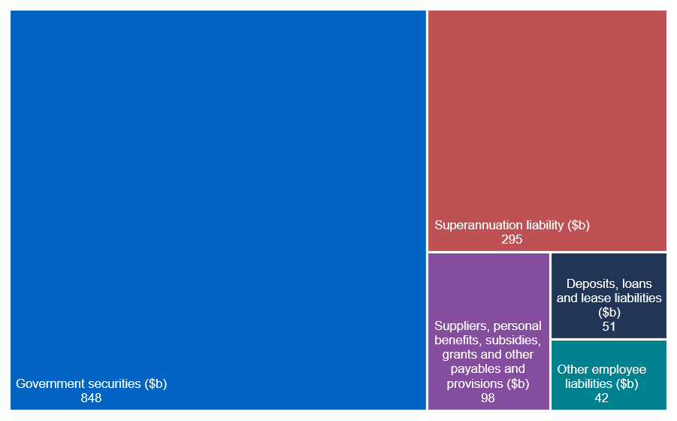

The Government’s major liabilities are Australian Government securities on issue (see Statement 7: Debt Statement for further information) and public sector employee superannuation liabilities.

Further information on the Government’s borrowings is provided in Statement 7: Debt Statement.

### Australian Government liabilities over the forward estimates

The budgeted composition of liabilities on the Australian Government’s balance sheet is provided in Chart 10B.5 below.

Chart 10B.5: Composition of Australian Government liabilities over the forward estimates

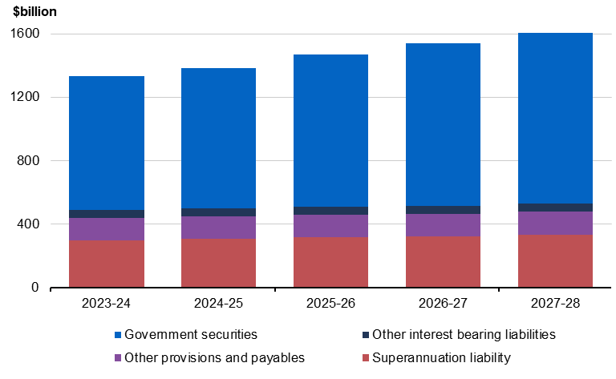

Note: Other interest bearing liabilities includes deposits held, loans and lease liabilities. Other provisions and payables includes other employee liabilities, suppliers payable, personal benefits payable, subsidies payable, grants payable, other payables and provisions.

#### Total liabilities are expected to grow consistently over the forward estimates, which is predominantly due to growth in government securities on issue and superannuation liabilities.

#### Government securities

Government securities on the Australian Government’s balance sheet reflect the market value of the Australian Government securities on issue, consistent with external reporting standards. Further detail on the face value of Australian Government securities can be found in Statement 7: Debt Statement.

#### Public sector employee superannuation liabilities

Public sector employee superannuation entitlements relating to past and present civilian employees and military personnel are a financial liability on the Government’s balance sheet. Total superannuation liabilities are projected to be $294.7 billion at 30 June 2024, $332.7 billion at 30 June 2028 and approximately $506.2 billion at 30 June 2060.

These liabilities represent the present value of future unfunded superannuation benefits relating to past and present employees and are based on an actuarially determined discount rate. The long-term nature of the unfunded superannuation liabilities requires the use of a discount rate that best matches the duration of the liabilities. The use of a long-term discount rate for budget purposes avoids the volatility that would occur by using current market yields on Government bonds. The value recorded on the balance sheet is highly sensitive to the discount rate used.

In preparing the latest Long Term Cost Reports for the civilian and military schemes, the scheme actuaries determined that a discount rate of 5.0 per cent should be applied.

The Australian Government has never fully funded its defined benefit scheme superannuation liabilities. However, the Future Fund was established in 2006 to help finance the Government’s unfunded superannuation liabilities.

For civilian employees, the major defined benefit schemes are the Commonwealth Superannuation Scheme and the Public Sector Superannuation Scheme. These schemes were closed to new members in 1990 and 2005 respectively. The Public Sector Superannuation Accumulation Plan was introduced on 1 July 2005 and provides fully funded accumulation benefits for new civilian employees from that date.

For military personnel, the defined benefit schemes are the Defence Force Retirement and Death Benefits Scheme, the Defence Forces Retirement Benefits Scheme and the Military Superannuation and Benefits Scheme (MSBS). Following the closure of the MSBS on 30 June 2016, all defined benefit military schemes are now closed to new members. A new military superannuation accumulation scheme, Australian Defence Force (ADF) Super, commenced on 1 July 2016. ADF Super is accompanied by a statutory death and disability arrangement ADF cover.

While there have not been any new members to the public service and military defined benefit schemes since closure in 2005 and 2016 respectively, the Government’s unfunded superannuation liabilities are expected to grow as current members continue to accrue benefits prior to retirement. Consistent with the 2020 Long-Term Cost Reports, the unfunded liability for public service defined benefit schemes is projected to peak in the mid 2030’s, whilst the unfunded liability for military defined benefit schemes is projected to continue to increase over time to 2060. The present value of the superannuation liability is also sensitive to changes in the discount rate.

As the superannuation liabilities are included in the Government’s net worth and net financial worth aggregates, revaluations of the liabilities have an impact on these aggregates.

The value of superannuation liabilities by scheme is provided in Table 10B.3 below.

Table 10B.3: Superannuation liabilities by scheme

|  |  |  |  |  |  |
| --- | --- | --- | --- | --- | --- |
|  | Estimates | | | | |
|  | 2023‑24 | 2024‑25 | 2025‑26 | 2026‑27 | 2027‑28 |
|  | $m | $m | $m | $m | $m |
| Civilian superannuation schemes |  |  |  |  |  |
| Commonwealth Superannuation Scheme | 62,612 | 61,099 | 59,489 | 57,787 | 55,999 |
| Public Sector Superannuation Scheme | 96,691 | 102,271 | 108,537 | 113,238 | 117,994 |
| Parliamentary Contributory Superannuation |  |  |  |  |  |
| Scheme | 819 | 812 | 801 | 790 | 777 |
| Governors‑‑General Scheme | 14 | 23 | 23 | 22 | 22 |
| Judges’ Pensions Scheme | 1,244 | 1,286 | 1,329 | 1,374 | 1,421 |
| Division 2 Judges of the Federal Circuit   and Family Court of Australia Death   and Disability Scheme | 1 | 2 | 2 | 3 | 4 |
| Total civilian schemes | 161,380 | 165,492 | 170,181 | 173,214 | 176,218 |
| Military superannuation schemes |  |  |  |  |  |
| Military Superannuation and Benefits Scheme | 96,437 | 100,934 | 105,251 | 109,403 | 113,379 |
| Defence Force Retirement and Death Benefits |  |  |  |  |  |
| Scheme | 31,392 | 31,021 | 30,593 | 30,112 | 29,591 |
| Defence Forces Retirement Benefits Scheme | 229 | 212 | 196 | 181 | 167 |
| Australian Defence Force Cover | 4,982 | 6,483 | 8,340 | 10,576 | 13,194 |
| Total military schemes | 133,040 | 138,650 | 144,380 | 150,272 | 156,330 |
| Other schemes | 234 | 242 | 253 | 255 | 191 |
| **Total** | **294,654** | **304,384** | **314,814** | **323,741** | **332,739** |

#### Other provisions and payables

Other provisions and payables includes all other Government liabilities including lease liabilities, provisions for other employee entitlements such as leave, unpaid grants, subsidies, personal benefits, and payments to suppliers.